## 实验一 去掉血管及组织中的血管分量 得到图像-目的是验证图像出现空白是不是缺少点缘故

% Make the scatteres for a simulation and store

% it in a file for later simulation use

% Joergen Arendt Jensen, Feb. 26, 1997

load pht_data_zuzhi/pht_data_zuzhi.mat

load pht_data_zuzhi/pht_data_xueliu.mat

phantom_positions=phantom_positions_zuzhi;

phantom_amplitudes=phantom_amplitudes_zuzhi;

%%%%%%%%

eval(['save pht_data/pht_data' num2str(1) ' phantom_positions phantom_amplitudes'])

%首先找出血流中血流分量

liu_1=find(phantom_positions_xueliu(:,3)>=(55.5/1000) & phantom_positions_xueliu(:,3)<=(64.5/1000));

phantom_positions_xueliu=phantom_positions_xueliu([liu_1],:);

phantom_amplitudes_xueliu=phantom_amplitudes_xueliu([liu_1],:);

phantom_positions_xueliu_copy=phantom_positions_xueliu;

phantom_amplitudes_xueliu_copy=phantom_amplitudes_xueliu

%首先找出组织中组织分量 本次使用找出血流并删除的方法

zuzhi_1=find(phantom_positions_zuzhi(:,3)>=(55.5/1000) & phantom_positions_zuzhi(:,3)<=(64.5/1000));

phantom_positions_zuzhi([zuzhi_1],:)=[];

phantom_amplitudes_zuzhi([zuzhi_1],:)=[];

phantom_positions_zuzhi_copy=phantom_positions_zuzhi;

phantom_amplitudes_zuzhi_copy=phantom_amplitudes_zuzhi;

% [phantom_positions, phantom_amplitudes] = cyst_pht(100000);

%定义血流位移量

vp=50/1000;

R=4.5/1000;%cyst_pht.m--r1=9/2/1000;

dz=R/25

for i=1:25

vr(i)=vp*(1-((dz*i)/R)^2);%定义的血流速度 抛物线函数

end

vr2=fliplr(vr);%翻转函数 翻转就是[1 2 3]翻转之后就是[3 2 1]

vr1=[vr2,vr];%将两个抛物线拼起来

s=[];

for i=1:50

t=1/20;%制作20张图 所以时间是1/20

s(i)=vr1(i)*t;%算出血流的位移量

end

% for j=1:20

phantom_positions_zuzhi=phantom_positions_zuzhi_copy;

phantom_amplitudes_zuzhi=phantom_amplitudes_zuzhi_copy;

phantom_positions_xueliu=phantom_positions_xueliu_copy;

phantom_amplitudes_xueliu=phantom_amplitudes_xueliu_copy;

% for i=1:50%血流的位移量-血流在血管内部散射点向是向X轴变化

% h=find(phantom_positions_xueliu(:,3)>=(55.5/1000+dz*(i-1)) & phantom_positions_xueliu(:,3)<=(55.5/1000+dz*i));

% phantom_positions_xueliu(h,1)=phantom_positions_xueliu(h,1)+j*s(i);

% %此处找出h中 也就是血管内的变量中流出血管的值

% % %find(phantom_positions(h,1)>20/1000 )这句已经把其重新排序了

% % h1=find(phantom_positions(h,1)>20/1000 );

% % h3=h(h1);

% % %此处相当于就找出来原来在那里的值所对应的序号

% % phantom_positions(h3,1)=-20/1000;

% end

% %找出那些是属于在选定范围内的

% h1=find(phantom_positions_xueliu(:,1)>=(25/1000) & phantom_positions_xueliu(:,1)<=(75/1000));

%

% choose_phantom_positions_xueliu=phantom_positions_xueliu([h1],:);

% phantom_positions=[phantom_positions_zuzhi;choose_phantom_positions_xueliu];

%

% choose_phantom_amplitudes_xueliu=phantom_amplitudes_xueliu([h1],:);

% phantom_amplitudes=[phantom_amplitudes_zuzhi;choose_phantom_amplitudes_xueliu]

%%这么些有问题 因为相当于直接将全部都重新开始了 所以要先把血管内的跳出来

%%%%%测试如果没有血流的样子

phantom_positions=phantom_positions_zuzhi;

phantom_amplitudes=phantom_amplitudes_zuzhi;

%%%%%%%%

eval(['save pht_data/pht_data' num2str(2) ' phantom_positions phantom_amplitudes'])

% end

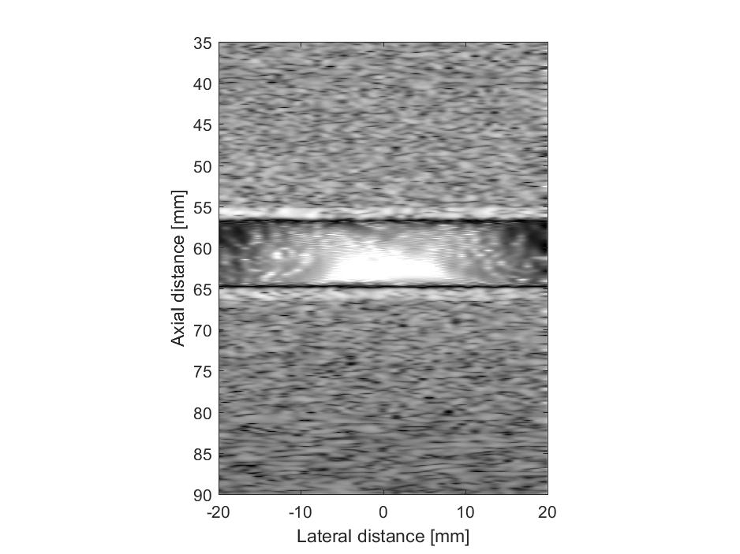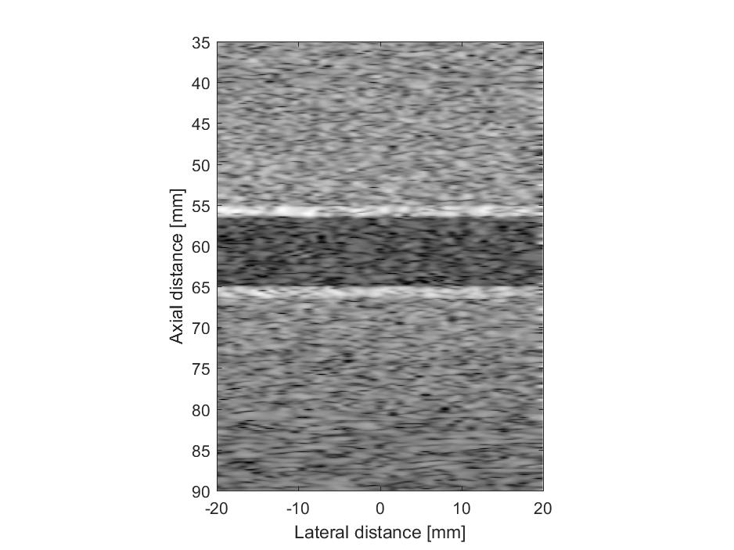

## 实验二：验证延长伸展替换的可行性

% Make the scatteres for a simulation and store

% it in a file for later simulation use

% Joergen Arendt Jensen, Feb. 26, 1997

load pht_data_zuzhi/pht_data_zuzhi.mat

% load pht_data_zuzhi/pht_data_xueliu.mat

% phantom_positions=phantom_positions_zuzhi;

% phantom_amplitudes=phantom_amplitudes_zuzhi;

%%%%%%%%

% eval(['save pht_data/pht_data' num2str(1) ' phantom_positions phantom_amplitudes'])

%首先找出血流中血流分量

% liu_1=find(phantom_positions_xueliu(:,3)>=(55.5/1000) & phantom_positions_xueliu(:,3)<=(64.5/1000));

% phantom_positions_xueliu=phantom_positions_xueliu([liu_1],:);

% phantom_amplitudes_xueliu=phantom_amplitudes_xueliu([liu_1],:);

% phantom_positions_xueliu_copy=phantom_positions_xueliu;

% phantom_amplitudes_xueliu_copy=phantom_amplitudes_xueliu;

%首先找出组织中组织分量 本次使用找出血流并删除的方法

zuzhi_1=find(phantom_positions_zuzhi(:,3)>=(55.5/1000) & phantom_positions_zuzhi(:,3)<=(64.5/1000));

tiaochu_phantom_positions_xueliu=phantom_positions_zuzhi([zuzhi_1],:);

tiaochu_phantom_amplitudes_xueliu=phantom_amplitudes_zuzhi([zuzhi_1]);

tiaochu_copy_phantom_positions_xueliu=tiaochu_phantom_positions_xueliu;

tiaochu_copy_phantom_positions_xueliu(:,1)=tiaochu_copy_phantom_positions_xueliu(:,1)-50/1000;

% temp1_phantom_amplitudes_xueliu=phantom_amplitudes_zuzhi([zuzhi_1],:);

result_phantom_positions_xueliu=[tiaochu_phantom_positions_xueliu;tiaochu_copy_phantom_positions_xueliu];

result_phantom_amplitudes_xueliu=[tiaochu_phantom_amplitudes_xueliu;tiaochu_phantom_amplitudes_xueliu];

% phantom_positions_zuzhi([zuzhi_1],:)=[];

% phantom_amplitudes_zuzhi([zuzhi_1],:)=[];

% phantom_positions_zuzhi_copy=phantom_positions_zuzhi;

% phantom_amplitudes_zuzhi_copy=phantom_amplitudes_zuzhi;

% [phantom_positions, phantom_amplitudes] = cyst_pht(100000);

%定义血流位移量

vp=50/1000;

R=4.5/1000;%cyst_pht.m--r1=9/2/1000;

dz=R/25

for i=1:25

vr(i)=vp*(1-((dz*i)/R)^2);%定义的血流速度 抛物线函数

end

vr2=fliplr(vr);%翻转函数 翻转就是[1 2 3]翻转之后就是[3 2 1]

vr1=[vr2,vr];%将两个抛物线拼起来

s=[];

for i=1:50

t=1/20;%制作20张图 所以时间是1/20

s(i)=vr1(i)*t;%算出血流的位移量

end

for j=1:20

% phantom_positions_zuzhi=phantom_positions_zuzhi_copy;

% phantom_amplitudes_zuzhi=phantom_amplitudes_zuzhi_copy;

% phantom_positions_xueliu=phantom_positions_xueliu_copy;

% phantom_amplitudes_xueliu=phantom_amplitudes_xueliu_copy;

% for i=1:50%血流的位移量-血流在血管内部散射点向是向X轴变化

% h=find(phantom_positions_xueliu(:,3)>=(55.5/1000+dz*(i-1)) & phantom_positions_xueliu(:,3)<=(55.5/1000+dz*i));

% phantom_positions_xueliu(h,1)=phantom_positions_xueliu(h,1)+j*s(i);

% %此处找出h中 也就是血管内的变量中流出血管的值

% % %find(phantom_positions(h,1)>20/1000 )这句已经把其重新排序了

% % h1=find(phantom_positions(h,1)>20/1000 );

% % h3=h(h1);

% % %此处相当于就找出来原来在那里的值所对应的序号

% % phantom_positions(h3,1)=-20/1000;

% end

% %找出那些是属于在选定范围内的

h1=find(result_phantom_positions_xueliu(:,1)>=(-30/1000) & result_phantom_positions_xueliu(:,1)<=(20/1000));

%

choose_phantom_positions_xueliu=result_phantom_positions_xueliu([h1],:);

choose_phantom_amplitudes_xueliu=result_phantom_amplitudes_xueliu([h1],:);

phantom_positions_zuzhi([zuzhi_1],:)=choose_phantom_positions_xueliu;

phantom_amplitudes_zuzhi([zuzhi_1],:)=choose_phantom_amplitudes_xueliu;

phantom_positions=phantom_positions_zuzhi;

phantom_amplitudes=phantom_amplitudes_zuzhi;

% choose_phantom_amplitudes_xueliu=phantom_amplitudes_xueliu([h1],:);

% phantom_amplitudes=[phantom_amplitudes_zuzhi;choose_phantom_amplitudes_xueliu]

%%这么些有问题 因为相当于直接将全部都重新开始了 所以要先把血管内的跳出来

% %%%%%测试如果没有血流的样子

% phantom_positions=phantom_positions_zuzhi;

% phantom_amplitudes=phantom_amplitudes_zuzhi;

% %%%%%%%%

eval(['save pht_data/pht_data' num2str(j) ' phantom_positions phantom_amplitudes'])

end

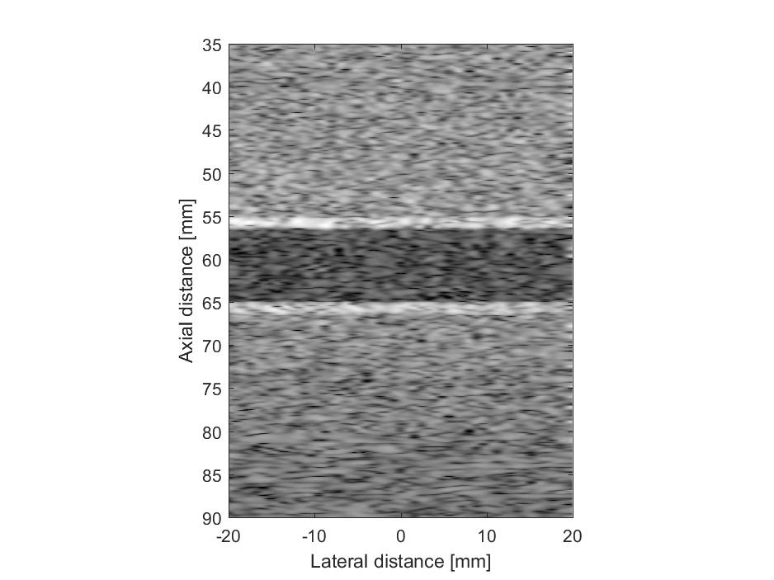

## 实验三 x如果移动必定报错 带有下标的赋值维度不匹配 即h1=9029 不等于9999 疑问

% Make the scatteres for a simulation and store

% it in a file for later simulation use

clear;clc;

% Joergen Arendt Jensen, Feb. 26, 1997

load pht_data_zuzhi/pht_data_zuzhi.mat

% load pht_data_zuzhi/pht_data_xueliu.mat

% phantom_positions=phantom_positions_zuzhi;

% phantom_amplitudes=phantom_amplitudes_zuzhi;

%%%%%%%%

% eval(['save pht_data/pht_data' num2str(1) ' phantom_positions phantom_amplitudes'])

%首先找出血流中血流分量

% liu_1=find(phantom_positions_xueliu(:,3)>=(55.5/1000) & phantom_positions_xueliu(:,3)<=(64.5/1000));

% phantom_positions_xueliu=phantom_positions_xueliu([liu_1],:);

% phantom_amplitudes_xueliu=phantom_amplitudes_xueliu([liu_1],:);

% phantom_positions_xueliu_copy=phantom_positions_xueliu;

% phantom_amplitudes_xueliu_copy=phantom_amplitudes_xueliu;

%首先找出组织中组织分量 本次使用找出血流并删除的方法

zuzhi_1=find(phantom_positions_zuzhi(:,3)>=(55.5/1000) & phantom_positions_zuzhi(:,3)<=(64.5/1000));

tiaochu_phantom_positions_xueliu=phantom_positions_zuzhi([zuzhi_1],:);

tiaochu_phantom_amplitudes_xueliu=phantom_amplitudes_zuzhi([zuzhi_1]);

tiaochu_copy_phantom_positions_xueliu=tiaochu_phantom_positions_xueliu;

tiaochu_copy_phantom_positions_xueliu(:,1)=tiaochu_copy_phantom_positions_xueliu(:,1)-50/1000;

% temp1_phantom_amplitudes_xueliu=phantom_amplitudes_zuzhi([zuzhi_1],:);

result_phantom_positions_xueliu=[tiaochu_phantom_positions_xueliu;tiaochu_copy_phantom_positions_xueliu];

result_phantom_amplitudes_xueliu=[tiaochu_phantom_amplitudes_xueliu;tiaochu_phantom_amplitudes_xueliu];

down=find(result_phantom_positions_xueliu(:,1)>=(-30/1000) & result_phantom_positions_xueliu(:,1)<=(20/1000));

% phantom_positions_zuzhi([zuzhi_1],:)=[];

% phantom_amplitudes_zuzhi([zuzhi_1],:)=[];

% phantom_positions_zuzhi_copy=phantom_positions_zuzhi;

% phantom_amplitudes_zuzhi_copy=phantom_amplitudes_zuzhi;

% [phantom_positions, phantom_amplitudes] = cyst_pht(100000);

result_phantom_positions_xueliu_copy=result_phantom_positions_xueliu;

result_phantom_amplitudes_xueliu_copy=result_phantom_amplitudes_xueliu;

vp=50/1000;%不要把血流速度弄那么大，刚好20帧，打算成像20张图

R=4.5/1000;%cyst_pht.m--r1=9/2/1000;

dz=R/25%血管内的血流分成50份，每份的宽度

L_X=50/1000;%血管总长

dx=L_X/300;%长度为50的组织分成300份

vp_1=1/1000;%组织及血管的最大位移

vr_vessel=zeros(1000,20);%500线 20张图所以有20个状态

for i=1:20

k5=abs(i-21);

w(i)=k5;

end

%%%%%定义血管内血流的位移%%%%%%%%%%%%%%%%%%%%%%%%%

for i=1:25

vr(i)=vp*(1-((dz*i)/R)^2);%定义的血流速度 抛物线函数

end

vr2=fliplr(vr);%翻转函数 翻转就是[1 2 3]翻转之后就是[3 2 1]

vr1=[vr2,vr];%将两个抛物线拼起来

s=[];

for i=1:50

dt=1/20;%20张图 所以每张图1/20秒

s(i)=vr1(i)*dt;%算出血流的位移量

end

%%%%%%%%%%%%%%%%%%%%%%%%%%%%%%%%%%%%%%%%%%%%%%%%%

for j=1:20%%为了便于观察 第一张图不变

% phantom_positions_zuzhi=phantom_positions_zuzhi_copy;

% phantom_amplitudes_zuzhi=phantom_amplitudes_zuzhi_copy;

% phantom_positions_xueliu=phantom_positions_xueliu_copy;

% phantom_amplitudes_xueliu=phantom_amplitudes_xueliu_copy;

% for i=1:50%血流的位移量-血流在血管内部散射点向是向X轴变化

% h=find(phantom_positions_xueliu(:,3)>=(55.5/1000+dz*(i-1)) & phantom_positions_xueliu(:,3)<=(55.5/1000+dz*i));

% phantom_positions_xueliu(h,1)=phantom_positions_xueliu(h,1)+j*s(i);

% %此处找出h中 也就是血管内的变量中流出血管的值

% % %find(phantom_positions(h,1)>20/1000 )这句已经把其重新排序了

% % h1=find(phantom_positions(h,1)>20/1000 );

% % h3=h(h1);

% % %此处相当于就找出来原来在那里的值所对应的序号

% % phantom_positions(h3,1)=-20/1000;

% end

% %找出那些是属于在选定范围内的

%%********************************模块一：血流位移**************************************

% for i=1:50%血流的位移量-血流在血管内部散射点向是向X轴变化

% h=find(result_phantom_positions_xueliu(:,3)>=(55.5/1000+dz*(i-1)) & result_phantom_positions_xueliu(:,3)<(55.5/1000+dz*i));

% result_phantom_positions_xueliu(h,1)=result_phantom_positions_xueliu(h,1)+(j-1)*5*s(i);

% end

%%**************************************end**************************************

% for i=1:50%血流的位移量-血流在血管内部散射点向是向X轴变化

% h=find(result_phantom_positions_xueliu(:,3)>=(55.5/1000+dz*(i-1)) & result_phantom_positions_xueliu(:,3)<(55.5/1000+dz*i));

result_phantom_positions_xueliu(:,1)=result_phantom_positions_xueliu(:,1)+5/1000;

% end

%找到属于-25/1000到25/1000之间的点

h1=find(result_phantom_positions_xueliu(:,1)>=(-25/1000) & result_phantom_positions_xueliu(:,1)<=(25/1000));

%

choose_phantom_positions_xueliu=result_phantom_positions_xueliu([h1],:);

choose_phantom_amplitudes_xueliu=result_phantom_amplitudes_xueliu([h1],:);

phantom_positions_zuzhi([zuzhi_1],:)=choose_phantom_positions_xueliu;

phantom_amplitudes_zuzhi([zuzhi_1],:)=choose_phantom_amplitudes_xueliu;

phantom_positions=phantom_positions_zuzhi;

phantom_amplitudes=phantom_amplitudes_zuzhi;

% choose_phantom_amplitudes_xueliu=phantom_amplitudes_xueliu([h1],:);

% phantom_amplitudes=[phantom_amplitudes_zuzhi;choose_phantom_amplitudes_xueliu]

%%这么些有问题 因为相当于直接将全部都重新开始了 所以要先把血管内的跳出来

% %%%%%测试如果没有血流的样子

% phantom_positions=phantom_positions_zuzhi;

% phantom_amplitudes=phantom_amplitudes_zuzhi;

% %%%%%%%%

eval(['save pht_data/pht_data' num2str(j) ' phantom_positions phantom_amplitudes'])

end

## 实验四 等差移动选取方法可行 sum=9999

% Make the scatteres for a simulation and store

% it in a file for later simulation use

clear;clc;

% Joergen Arendt Jensen, Feb. 26, 1997

load pht_data_zuzhi/pht_data_zuzhi.mat

% load pht_data_zuzhi/pht_data_xueliu.mat

% phantom_positions=phantom_positions_zuzhi;

% phantom_amplitudes=phantom_amplitudes_zuzhi;

%%%%%%%%

% eval(['save pht_data/pht_data' num2str(1) ' phantom_positions phantom_amplitudes'])

%首先找出血流中血流分量

% liu_1=find(phantom_positions_xueliu(:,3)>=(55.5/1000) & phantom_positions_xueliu(:,3)<=(64.5/1000));

% phantom_positions_xueliu=phantom_positions_xueliu([liu_1],:);

% phantom_amplitudes_xueliu=phantom_amplitudes_xueliu([liu_1],:);

% phantom_positions_xueliu_copy=phantom_positions_xueliu;

% phantom_amplitudes_xueliu_copy=phantom_amplitudes_xueliu;

%首先找出组织中组织分量 本次使用找出血流并删除的方法

zuzhi_1=find(phantom_positions_zuzhi(:,3)>=(55.5/1000) & phantom_positions_zuzhi(:,3)<=(64.5/1000));

tiaochu_phantom_positions_xueliu=phantom_positions_zuzhi([zuzhi_1],:);

tiaochu_phantom_amplitudes_xueliu=phantom_amplitudes_zuzhi([zuzhi_1]);

tiaochu_copy_phantom_positions_xueliu=tiaochu_phantom_positions_xueliu;

tiaochu_copy_phantom_positions_xueliu(:,1)=tiaochu_copy_phantom_positions_xueliu(:,1)-50/1000;

% temp1_phantom_amplitudes_xueliu=phantom_amplitudes_zuzhi([zuzhi_1],:);

result_phantom_positions_xueliu=[tiaochu_phantom_positions_xueliu;tiaochu_copy_phantom_positions_xueliu];

result_phantom_amplitudes_xueliu=[tiaochu_phantom_amplitudes_xueliu;tiaochu_phantom_amplitudes_xueliu];

down=find(result_phantom_positions_xueliu(:,1)>=(-30/1000) & result_phantom_positions_xueliu(:,1)<=(20/1000));

% phantom_positions_zuzhi([zuzhi_1],:)=[];

% phantom_amplitudes_zuzhi([zuzhi_1],:)=[];

% phantom_positions_zuzhi_copy=phantom_positions_zuzhi;

% phantom_amplitudes_zuzhi_copy=phantom_amplitudes_zuzhi;

% [phantom_positions, phantom_amplitudes] = cyst_pht(100000);

result_phantom_positions_xueliu_copy=result_phantom_positions_xueliu;

result_phantom_amplitudes_xueliu_copy=result_phantom_amplitudes_xueliu;

vp=50/1000;%不要把血流速度弄那么大，刚好20帧，打算成像20张图

R=4.5/1000;%cyst_pht.m--r1=9/2/1000;

dz=R/25%血管内的血流分成50份，每份的宽度

L_X=50/1000;%血管总长

dx=L_X/300;%长度为50的组织分成300份

vp_1=1/1000;%组织及血管的最大位移

vr_vessel=zeros(1000,20);%500线 20张图所以有20个状态

for i=1:20

k5=abs(i-21);

w(i)=k5;

end

%%%%%定义血管内血流的位移%%%%%%%%%%%%%%%%%%%%%%%%%

for i=1:25

vr(i)=vp*(1-((dz*i)/R)^2);%定义的血流速度 抛物线函数

end

vr2=fliplr(vr);%翻转函数 翻转就是[1 2 3]翻转之后就是[3 2 1]

vr1=[vr2,vr];%将两个抛物线拼起来

s=[];

for i=1:50

dt=1/20;%20张图 所以每张图1/20秒

s(i)=vr1(i)*dt;%算出血流的位移量

end

%%%%%%%%%%%%%%%%%%%%%%%%%%%%%%%%%%%%%%%%%%%%%%%%%

for j=4:4%%为了便于观察 第一张图不变

% phantom_positions_zuzhi=phantom_positions_zuzhi_copy;

% phantom_amplitudes_zuzhi=phantom_amplitudes_zuzhi_copy;

% phantom_positions_xueliu=phantom_positions_xueliu_copy;

% phantom_amplitudes_xueliu=phantom_amplitudes_xueliu_copy;

% for i=1:50%血流的位移量-血流在血管内部散射点向是向X轴变化

% h=find(phantom_positions_xueliu(:,3)>=(55.5/1000+dz*(i-1)) & phantom_positions_xueliu(:,3)<=(55.5/1000+dz*i));

% phantom_positions_xueliu(h,1)=phantom_positions_xueliu(h,1)+j*s(i);

% %此处找出h中 也就是血管内的变量中流出血管的值

% % %find(phantom_positions(h,1)>20/1000 )这句已经把其重新排序了

% % h1=find(phantom_positions(h,1)>20/1000 );

% % h3=h(h1);

% % %此处相当于就找出来原来在那里的值所对应的序号

% % phantom_positions(h3,1)=-20/1000;

% end

% %找出那些是属于在选定范围内的

%%********************************模块一：血流位移**************************************

% for i=1:50%血流的位移量-血流在血管内部散射点向是向X轴变化

% h=find(result_phantom_positions_xueliu(:,3)>=(55.5/1000+dz*(i-1)) & result_phantom_positions_xueliu(:,3)<(55.5/1000+dz*i));

% result_phantom_positions_xueliu(h,1)=result_phantom_positions_xueliu(h,1)+(j-1)*5*s(i);

% end

%%**************************************end**************************************

% for i=1:50%血流的位移量-血流在血管内部散射点向是向X轴变化

% h=find(result_phantom_positions_xueliu(:,3)>=(55.5/1000+dz*(i-1)) & result_phantom_positions_xueliu(:,3)<(55.5/1000+dz*i));

% result_phantom_positions_xueliu(:,1)=result_phantom_positions_xueliu(:,1)+5/1000;

% end

%找到属于-25/1000到25/1000之间的点

sum=0;

for i=1:50

%找出其中一线的所有点

h=find(result_phantom_positions_xueliu(:,3)>=(55.5/1000+dz*(i-1)) & result_phantom_positions_xueliu(:,3)<(55.5/1000+dz*i));

%找到其中索要截取的点

h2=find(result_phantom_positions_xueliu(h,1)>=((-25/1000)-(j-1)*s(i)) & result_phantom_positions_xueliu(h,1)<((25/1000)-(j-1)*s(i)));

%转换为原始向量中的点

h3=h(h2);

% h1=find(result_phantom_positions_xueliu(:,1)>=(-25/1000-5/1000) & result_phantom_positions_xueliu(:,1)<=(25/1000-5/1000));

% choose_phantom_positions_xueliu=result_phantom_positions_xueliu([h1],:);

% choose_phantom_amplitudes_xueliu=result_phantom_amplitudes_xueliu([h1],:);

% phantom_positions_zuzhi([zuzhi_1],:)=choose_phantom_positions_xueliu;

% phantom_amplitudes_zuzhi([zuzhi_1],:)=choose_phantom_amplitudes_xueliu;

sum=sum+length(h3(:));

end

phantom_positions=phantom_positions_zuzhi;

phantom_amplitudes=phantom_amplitudes_zuzhi;

% choose_phantom_amplitudes_xueliu=phantom_amplitudes_xueliu([h1],:);

% phantom_amplitudes=[phantom_amplitudes_zuzhi;choose_phantom_amplitudes_xueliu]

%%这么些有问题 因为相当于直接将全部都重新开始了 所以要先把血管内的跳出来

% %%%%%测试如果没有血流的样子

% phantom_positions=phantom_positions_zuzhi;

% phantom_amplitudes=phantom_amplitudes_zuzhi;

% %%%%%%%%

eval(['save pht_data/pht_data' num2str(j) ' phantom_positions phantom_amplitudes'])

end